GTS

Training User Guide
Generate HCM test scenarios through Business Process, Configuration Workbook, and User Story inputs
Version 1.0 | 19 August 2026

Index
1. Access GTS
1.1 Open the GenWizard development instance
1.2 Sign in
2. Generate Test Scenarios via Business Process
2.1 Select the Workday QA Agent
2.2 Select Generate Test Scenario and HCM
2.3 Select Business Process
2.4 Review the accepted HCM Business Process list
2.5 Select Business Processes and trigger generation
2.6 Download and review the output
3. Generate Test Scenarios via Configuration Workbook
4. Generate Test Scenarios via User Story
5. How to Input a File
6. GTS Access Issues

1. Access GTS

1.1 Open the GenWizard development instance
The GenWizard link varies depending on the instance being used. For the development instance, use the standard URL below:
https://platforms-dev.genwizard.accenture.com/chatbot/chat
1. Open the URL in a supported browser.
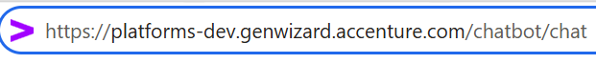
Figure 1. Open the standard GenWizard URL for the development instance.

1.2 Sign in
1. Enter the email address associated with the account.
2. Select Next and complete the assigned authentication method.
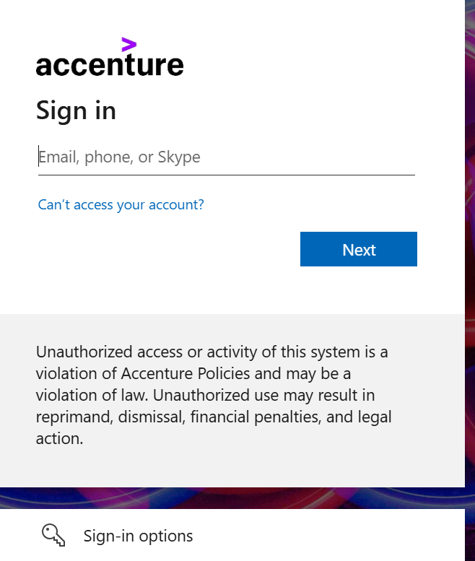
Figure 2. Sign in to GenWizard.

2. Generate Test Scenarios via Business Process
This section explains the complete process for generating HCM test scenarios by selecting one or more Workday Business Processes.

2.1 Select the Workday QA Agent
1. On the chatbot home page, select or enter @ to display the available personas.
2. Select Workday QA Agent.
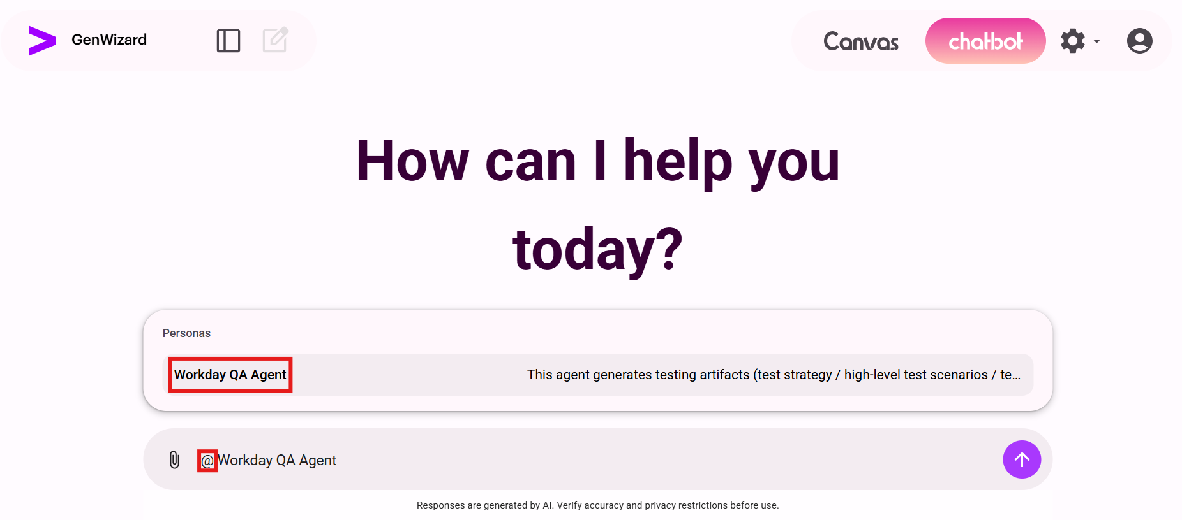
Figure 3. Select Workday QA Agent from the available personas.
3. Confirm that Workday QA Agent appears beside the @ symbol, enter trigger, and submit the message.
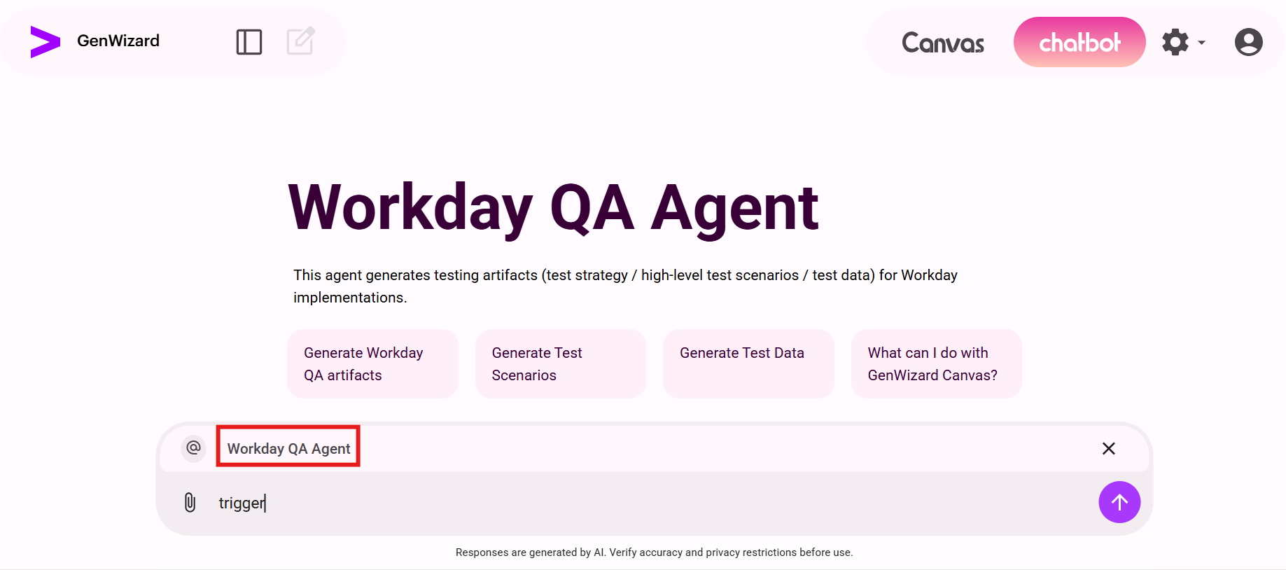
Figure 4. Trigger the selected Workday QA Agent.

2.2 Select Generate Test Scenario and HCM
1. When the agent asks what to generate, enter 1 to select Generate Test Scenario.
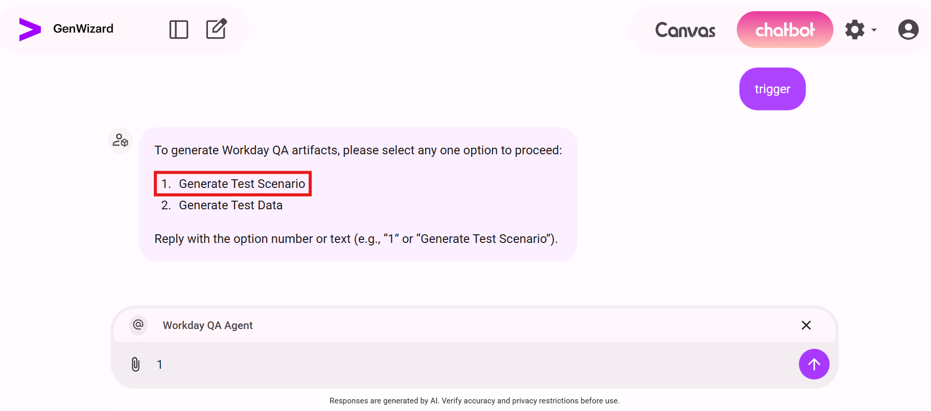
Figure 5. Select Generate Test Scenario.
2. When the agent asks for the module, enter 1 to select HCM.
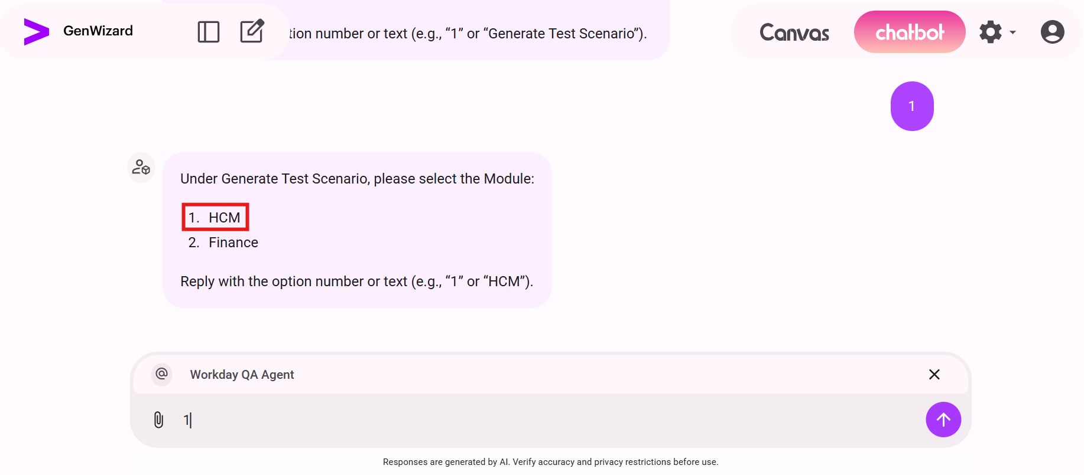
Figure 6. Select the HCM module.

2.3 Select Business Process
1. When the agent displays the available HCM methods, enter 3 to select Test Scenario via Business Process.
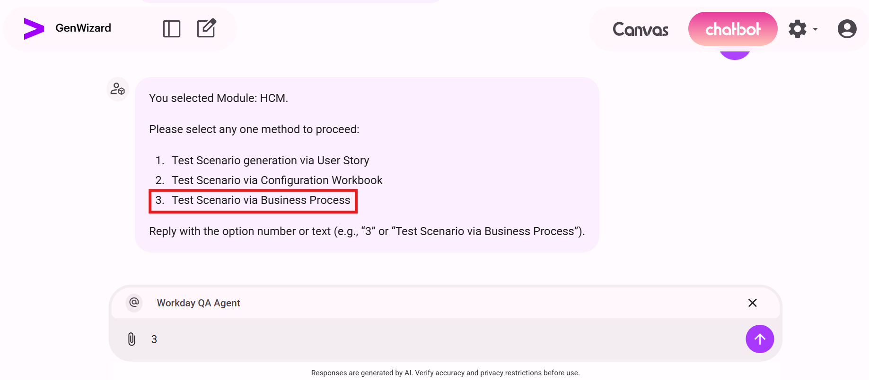
Figure 7. Select Test Scenario via Business Process.

2.4 Review the accepted HCM Business Process list
GTS displays the accepted HCM Business Process list. Select a minimum of one and a maximum of five Business Processes using the displayed number or the exact Business Process name. Separate multiple selections with commas.
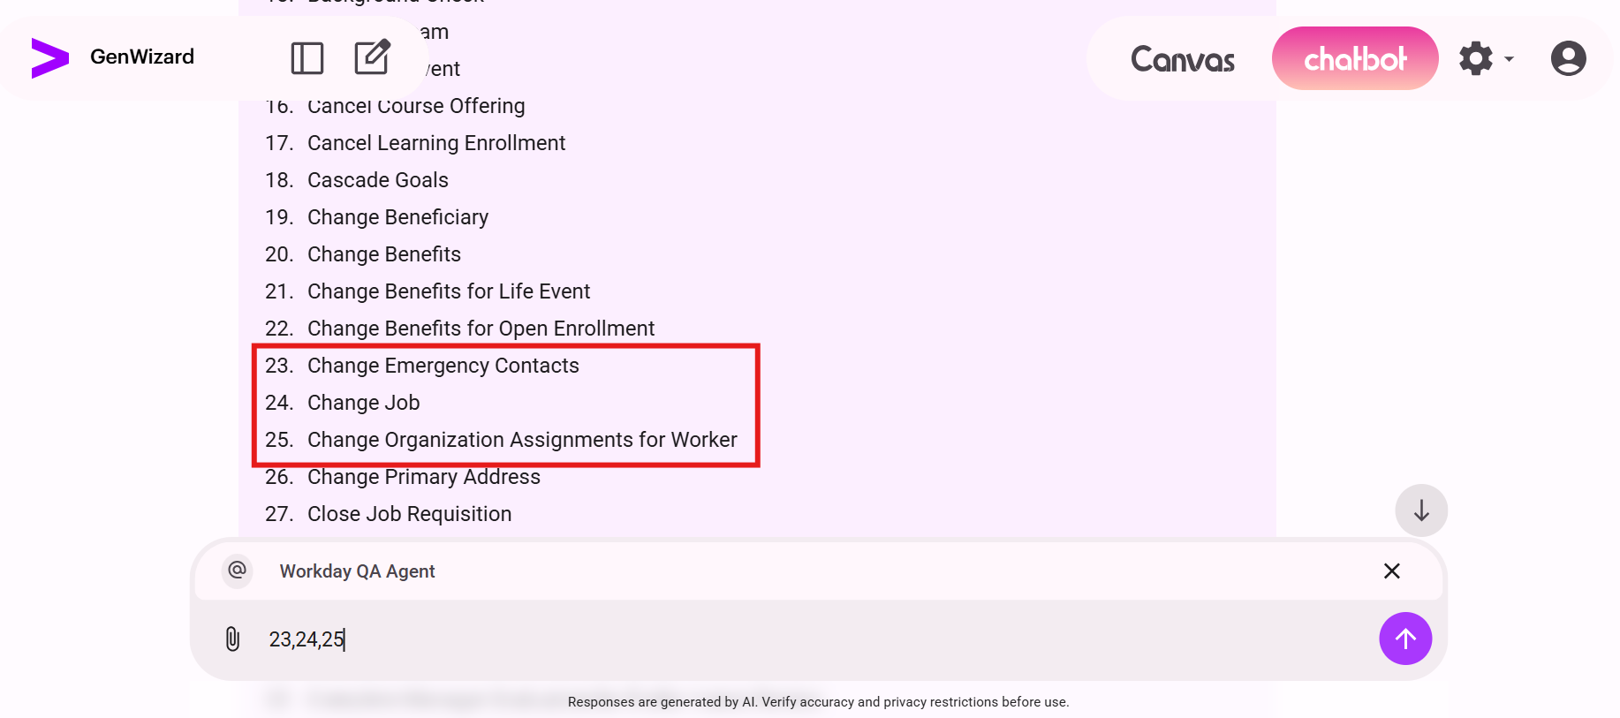
Figure 8. GTS introduces the accepted HCM Business Process list.

1. Absence Calendar
2. Add Additional Job
3. Assess Candidate
4. Assess My Team's Potential
5. Assess Potential
6. Assess Skills
7. Assign Costing Allocation
8. Assign Employee Collective Agreement
9. Assign Pay Group
10. Assign Roles
11. Assign Superior
12. Assign Work Schedule
13. Background Check
14. Calibrate Team
15. Campaign Event
16. Cancel Course Offering
17. Cancel Learning Enrollment
18. Cascade Goals
19. Change Beneficiary
20. Change Benefits
21. Change Benefits for Life Event
22. Change Benefits for Open Enrollment
23. Change Emergency Contacts
24. Change Job
25. Change Organization Assignments for Worker
26. Change Primary Address
27. Close Job Requisition
28. Close Position
29. Complete Form I-9
30. Complete Form I-9 Section 3
31. Complete Manager Evaluation for Disciplinary Action
32. Complete Manager Evaluation for Performance Review
33. Contact Change
34. Contract Contingent Worker
35. Correct Time Off
36. Create Position
37. Create Subordinate
38. Create Workday Account
39. Delegate Task
40. Dependent Event
41. Distribute Documents or Tasks
42. Drop Learning Enrollment
43. Edit Course Additional Data
44. Edit Course Offering Additional Data
45. Edit Government IDs
46. Edit Hiring Restrictions
47. Edit ID Information
48. Edit Licenses
49. Edit Notice Periods
50. Edit Other IDs
51. Edit Position
52. Edit Position Restrictions
53. Edit Workday Account
54. Employment Agreement
55. Employee Contract
56. End Additional Job
57. End Collective Agreement Assignment
58. End Contingent Worker Contract
59. Enter Time
60. Freeze Job Requisition
61. Freeze Position
62. Generate Document
63. Hire
64. Hiring Restrictions
65. Home Contact Change
66. Initiate Compensation Review Process
67. Interview
68. Job Application
69. Job Requisition
70. Job Requisition Change
71. Launch Calibration
72. Launch Talent Reviews
73. Legal Name Change
74. Manage Competencies
75. Manage Course
76. Manage Course Offering
77. Manage Goals
78. Manage Job Profile
79. Manage Lesson
80. Manage Probation Period
81. Manage Program
82. Marital Status Change
83. Mass Cancel Learning Enrollments
84. Move Worker (By Organization)
85. Move Worker (Supervisory)
86. Move Workers (By Organization)
87. Move Workers (Supervisory)
88. No Show
89. Offer
90. Onboarding
91. Onboarding Setup
92. Passports and Visa Change
93. Payment Election Enrollment Event
94. Personal Information Change
95. Propose Compensation Change
96. Propose Compensation Hire
97. Refer a Candidate
98. Request Compensation Change
99. Request Delegation Change
100. Request Leave of Absence
101. Request One Time Payment
102. Request One Time Payment Offer/Employment Agreement
103. Request Overtime
104. Request Return from Leave of Absence
105. Request Time Off
106. Review Candidate
107. Review Probation Period
108. Service Dates Change
109. Start Disciplinary Action
110. Start Performance Review
111. Submit Resignation
112. Talent Review
113. Termination
114. Title Change
115. Work Contact Change

2.5 Select Business Processes and trigger generation
1. Enter between one and five selections. Use the displayed number or the exact Business Process name.
2. For multiple Business Processes, separate the selections with commas. In the example, the user enters 23,24,25.
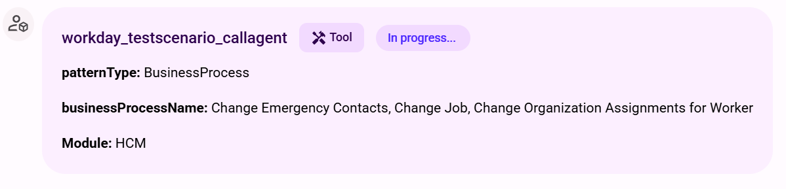
Figure 9. Enter the required Business Process selections.
3. After the selection is submitted, the workday_testscenario_callagent tool starts processing the request and displays In progress...
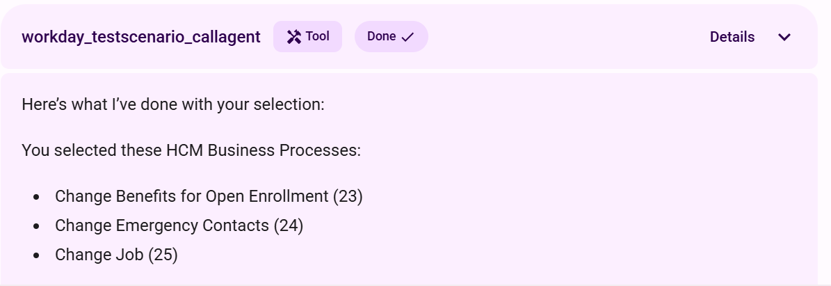
Figure 10. The tool shows the selected pattern, Business Processes, and HCM module while processing.
4. After the request is triggered, the tool status changes to Done and the agent provides a Trace ID for the request.
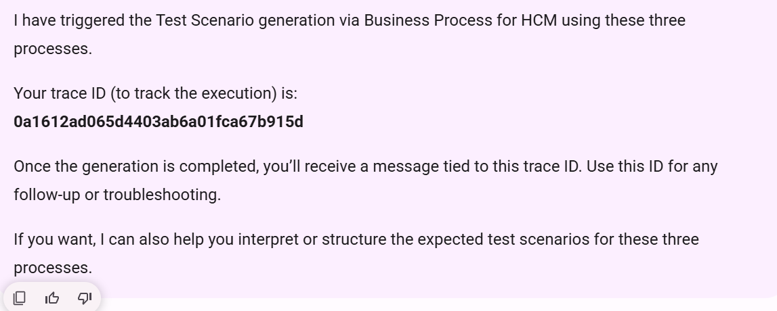
Figure 11. The tool status changes to Done after the request is triggered.
5. Review the acknowledgement confirming that test scenario generation has started.
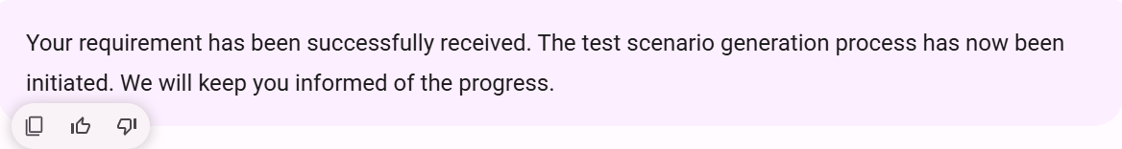
Figure 12. GTS confirms that the requirement has been received.

2.6 Download and review the output
1. After processing completes, select the required output link. The example highlights Download Test Scenarios Generated.
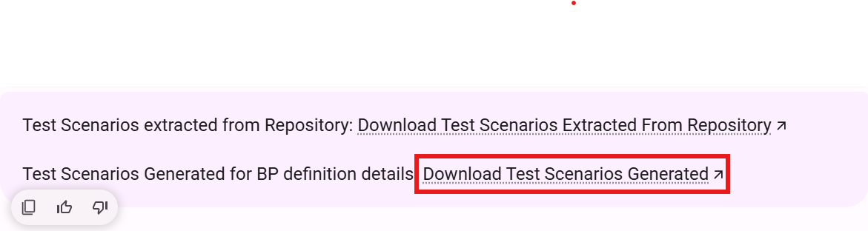
Figure 13. Select the link for the required generated test-scenario output.
2. The Agent Manager download page opens and the browser begins downloading the CSV file.
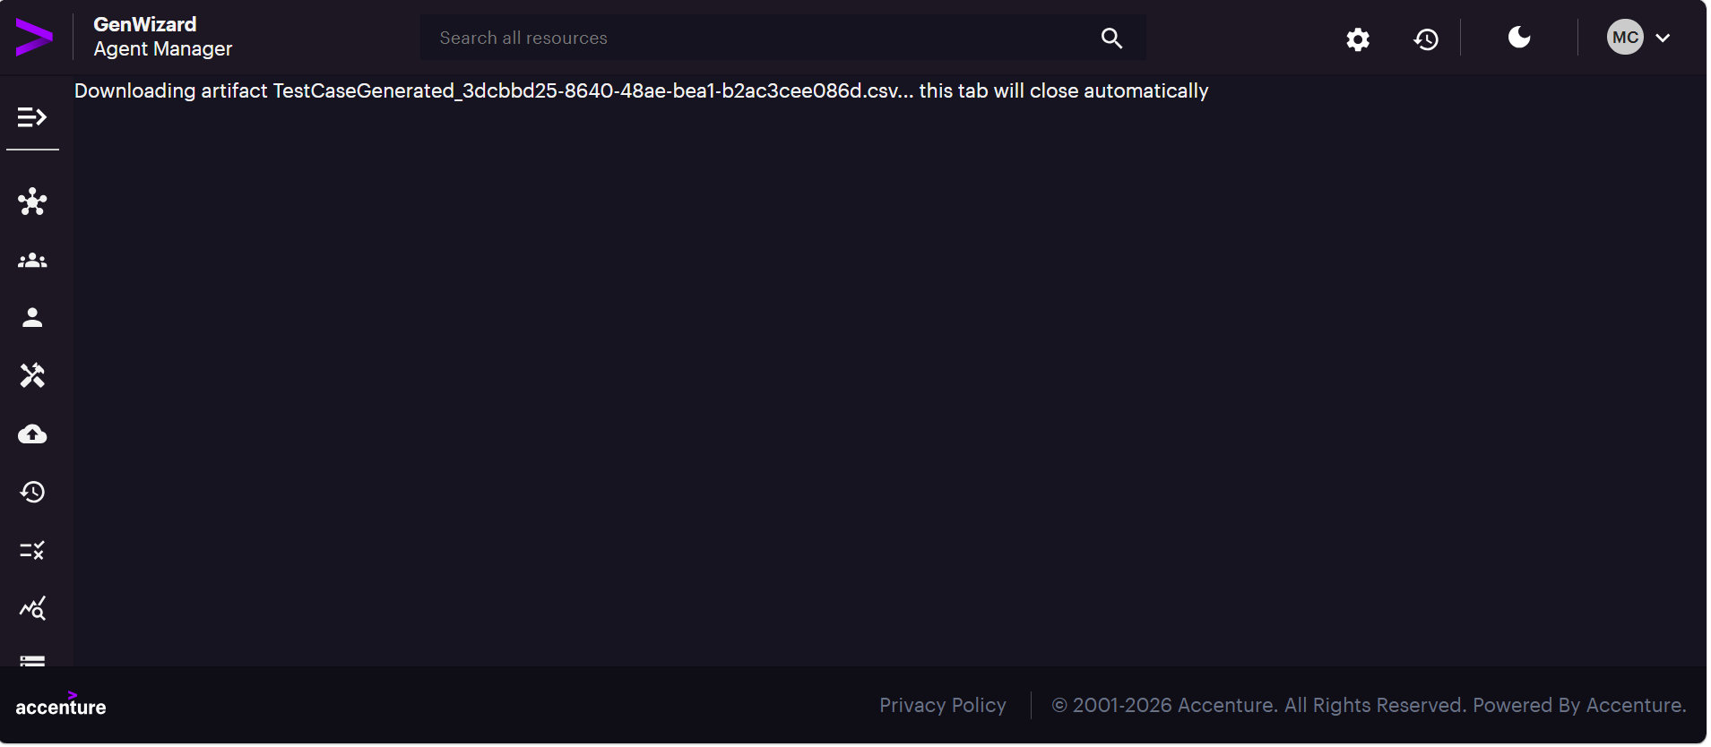
Figure 14. Agent Manager begins downloading the generated CSV file.
3. Open the downloaded CSV file and review the generated test scenarios.
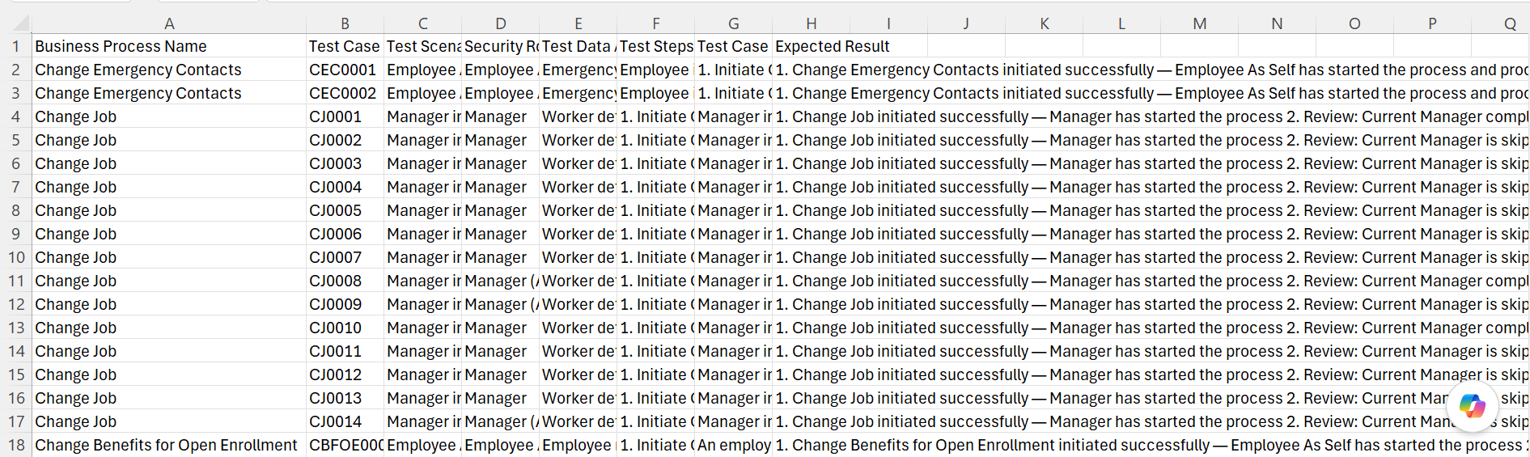
Figure 15. Generated Business Process test scenarios opened in Excel.

3. Generate Test Scenarios via Configuration Workbook
This process uses an HCM Configuration Workbook as the input. The conversation and output are shown below.
1. After selecting HCM, enter 2 to select Test Scenario via Configuration Workbook.
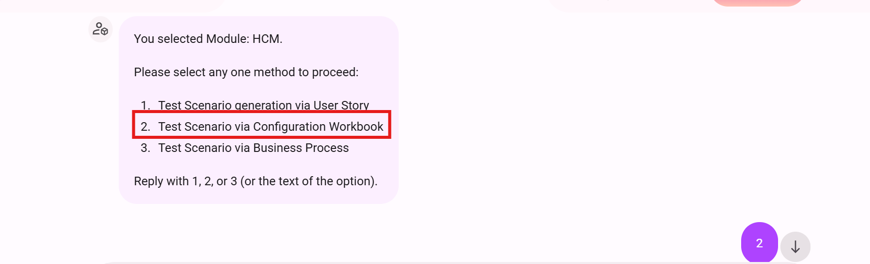
Figure 16. Select Test Scenario via Configuration Workbook.
2. Upload the Configuration Workbook in .xlsx format, add the file to the conversation, enter trigger, and submit the request.
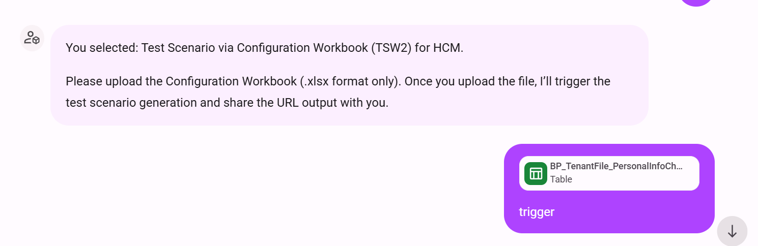
Figure 17. Attach the Configuration Workbook and trigger the request.
3. After the tool completes, select Download CSV.
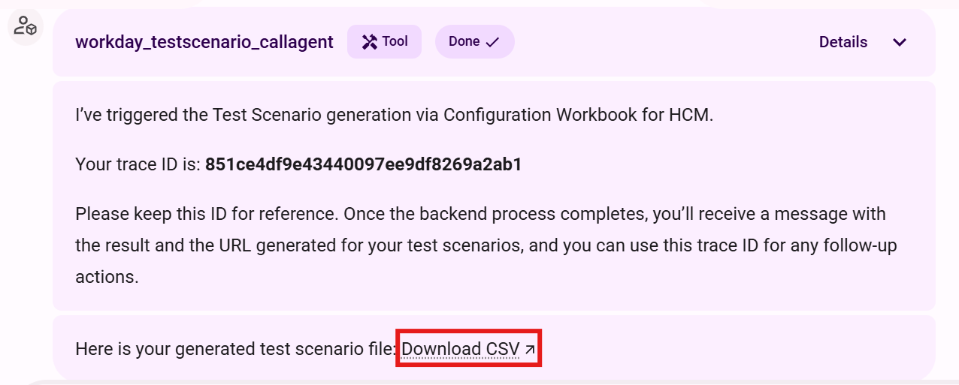
Figure 18. Select Download CSV after Configuration Workbook processing completes.
4. The Agent Manager download page begins downloading the generated CSV file.
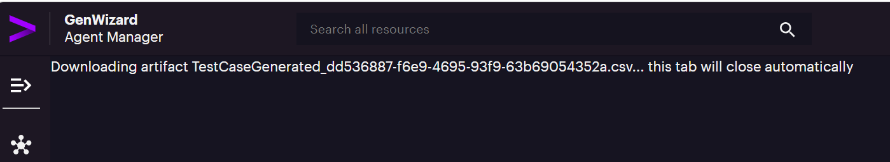
Figure 19. Agent Manager downloads the Configuration Workbook output.
5. Open the CSV file and review the generated test scenarios.
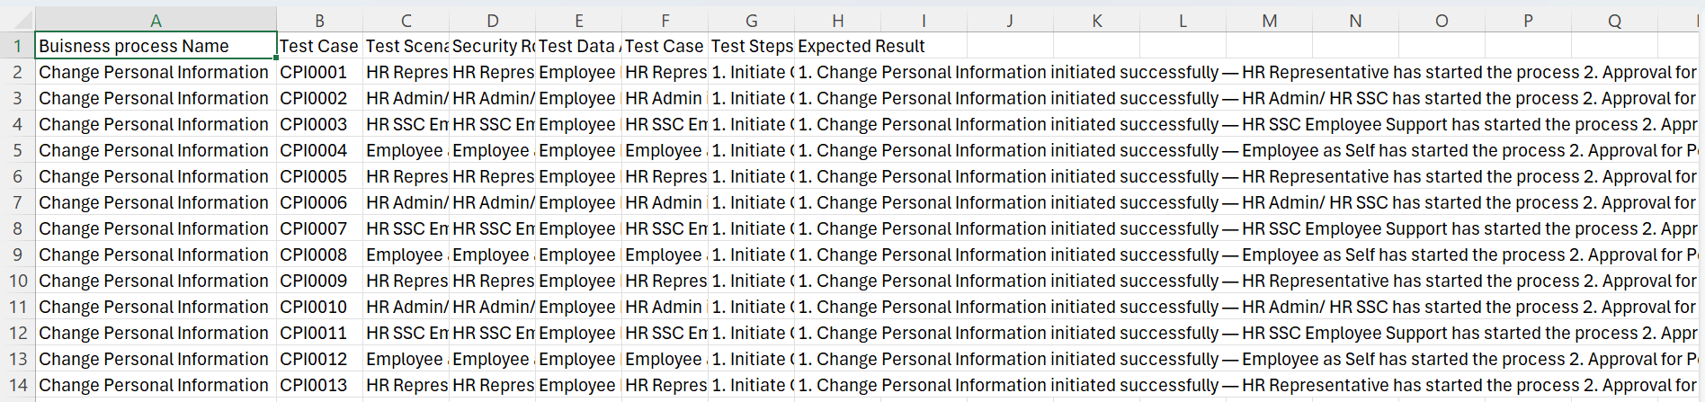
Figure 20. Configuration Workbook test-scenario output opened in Excel.

4. Generate Test Scenarios via User Story
This process uses an Excel file containing the User Story Title, Description, and Acceptance Criteria. The conversation and output are shown below.
1. After selecting HCM, enter 1 to select Test Scenario generation via User Story.
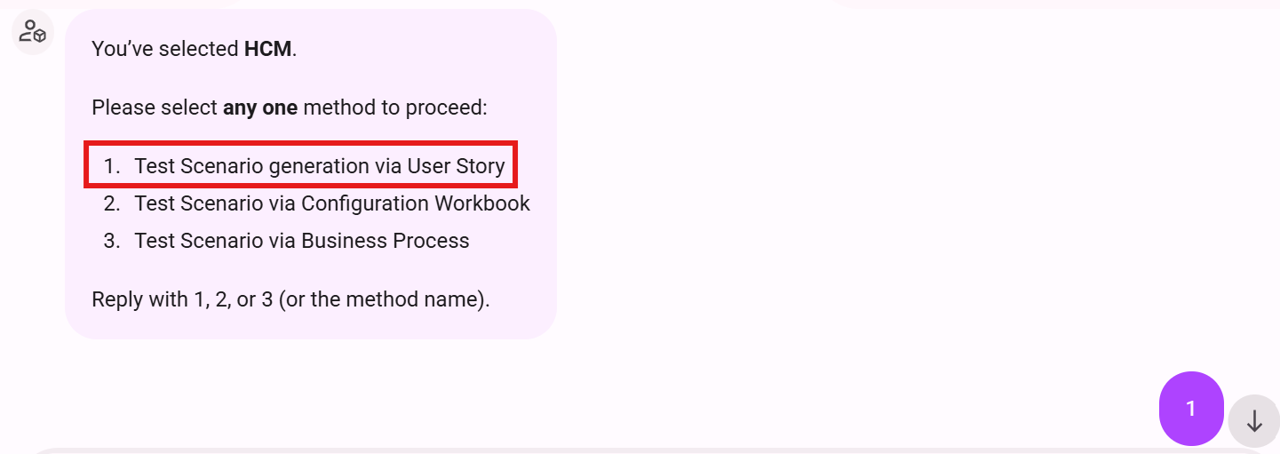
Figure 21. Select Test Scenario generation via User Story.
2. GTS requests an .xlsx file containing Title, Description, and Acceptance Criteria.
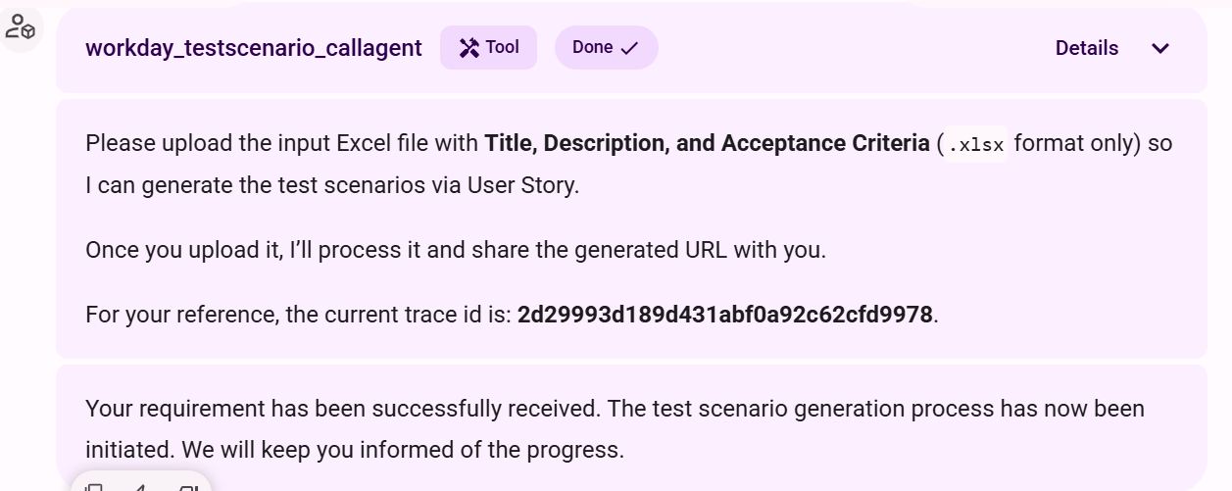
Figure 22. GTS requests the User Story input file.
3. Upload the User Story Excel file, add the file to the conversation, enter trigger, and submit the request.
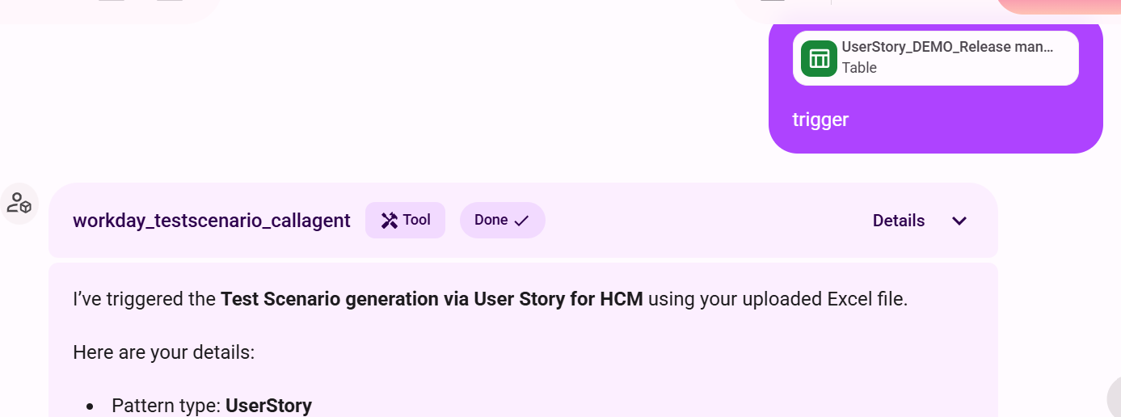
Figure 23. Attach the User Story input and trigger the request.
4. Review the completed tool response showing the UserStory pattern and HCM module.
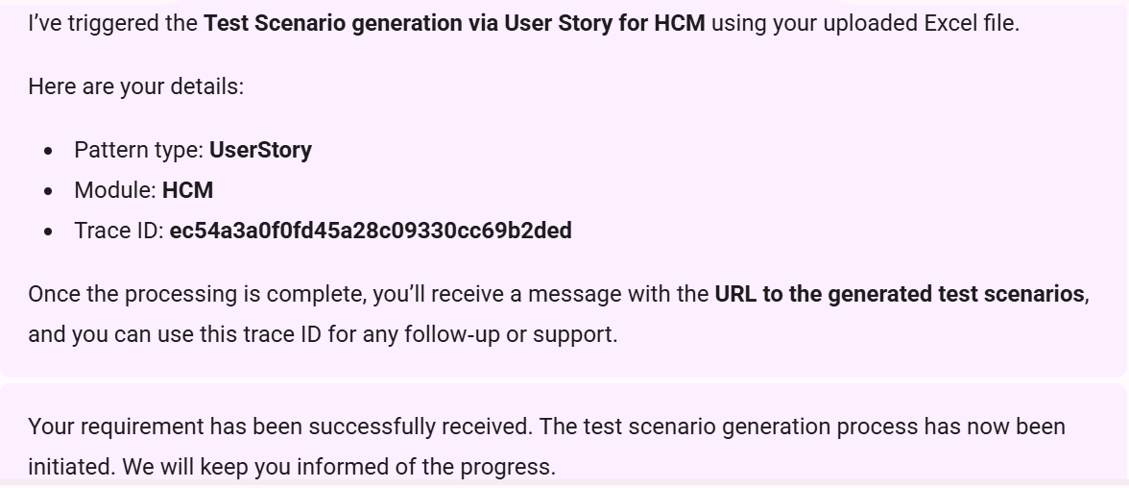
Figure 24. GTS confirms User Story test-scenario generation.
5. After processing completes, select Download Test Scenarios Extracted From Repository.
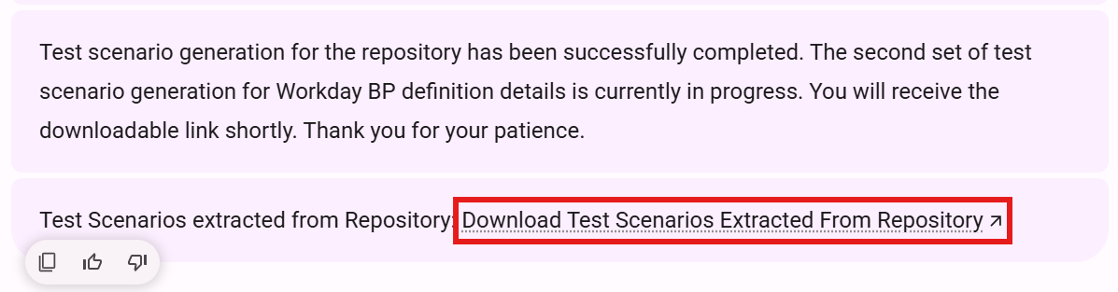
Figure 25. Select the repository test-scenario download link.
6. The Agent Manager page begins downloading the generated CSV file.
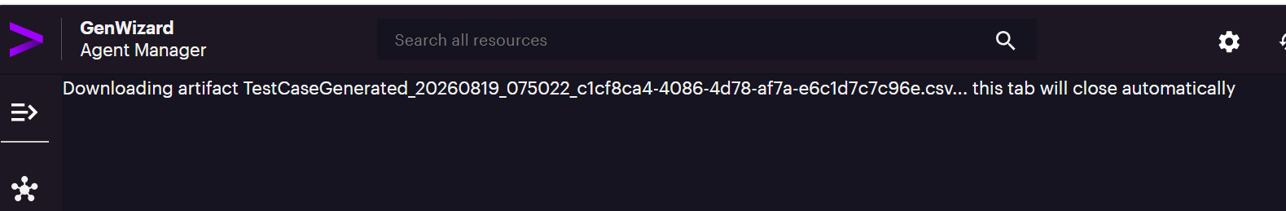
Figure 26. Agent Manager downloads the User Story output.
7. Open the CSV file and review the generated test scenarios.
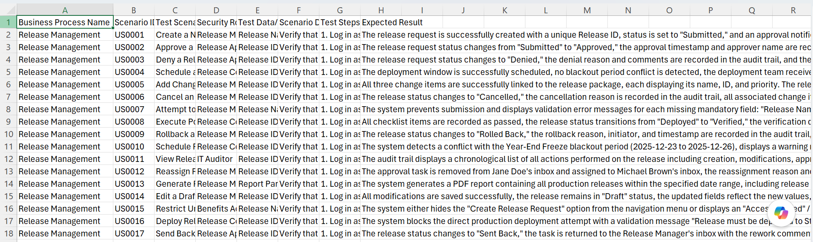
Figure 27. User Story test-scenario output opened in Excel.

5. How to Input a File
Use the following steps whenever GTS requests an input file for Configuration Workbook or User Story generation.
1. Select the Attach icon in the chatbot input.
2. In Add context to Assist GenAI, select Upload Files.
3. Select Drop files, or drag and drop the required file into the upload area.
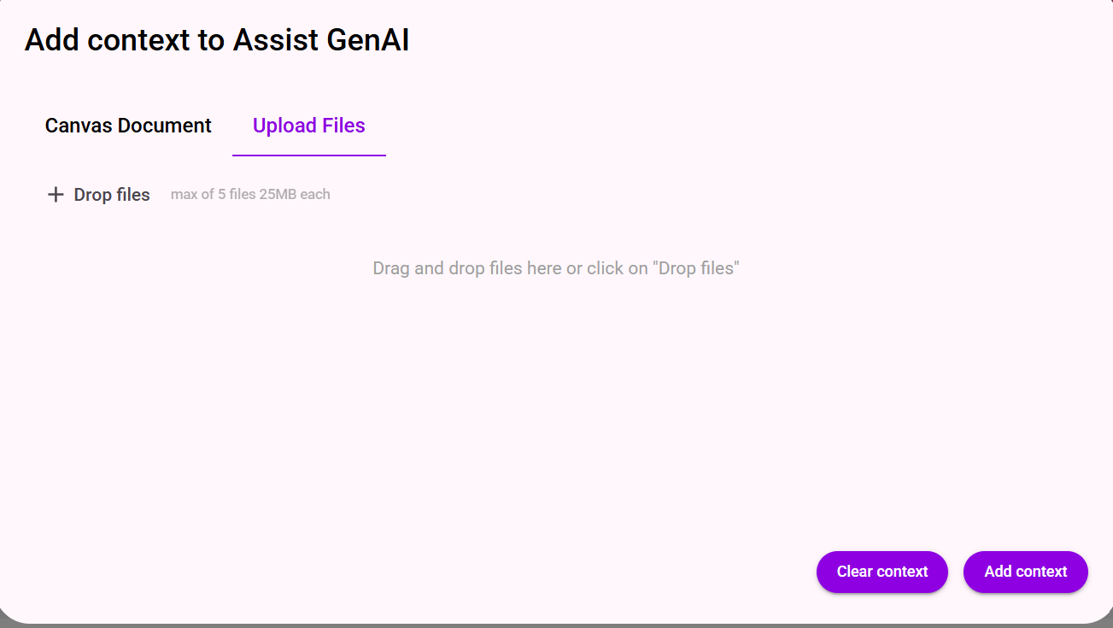
Figure 28. Open Upload Files and add the required file.
4. Confirm that the uploaded file is displayed, and then select Add context.
After Add context is selected, the file appears in the chatbot conversation, as shown in the Configuration Workbook and User Story examples.
5. Enter trigger and submit the request.

6. GTS Access Issues
For access-related issues, reach out to the following POCs:
First POC: s.pandurang.kaldhone@accenture.com
Second POC: ravissant.markenday@accenture.com

